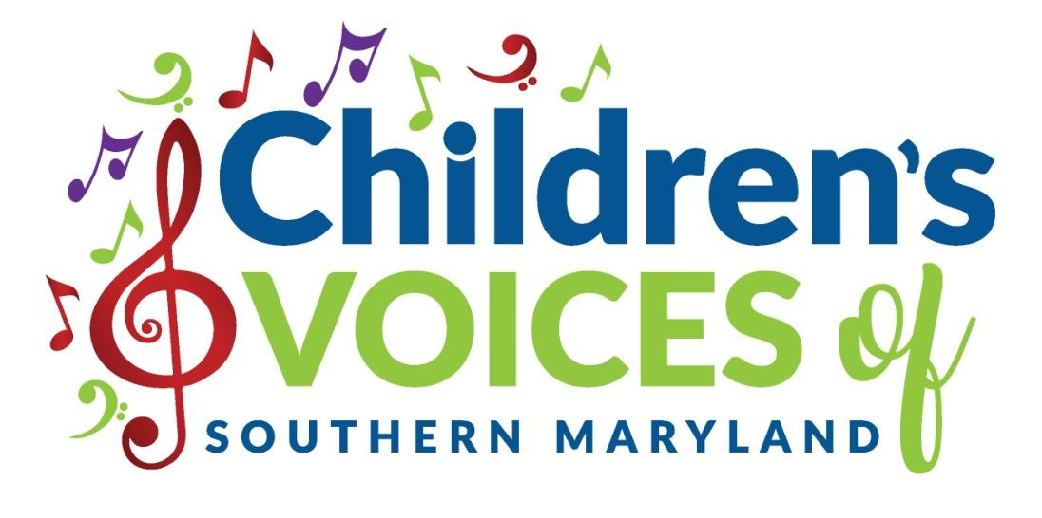
Registration Form for Spring Term, 2024
Student’s name _______________________________________________________________
Date of Birth _______________________________________ Age ______________________
School attending ______________________________________Grade Level_____________
Previous choral experience or musical training (piano lessons, etc.): ___________________________________________________________________________
Home address _______________________________________________________________
City__________________________ State_______ Zip Code__________________________
Parent or guardian name _______________________________________________________
Daytime phone__________________________________ Cell phone_______________________
E-mail address ________________________________________________________________
Parent or guardian name ________________________________________________________
Daytime phone__________________________________ Cell phone_______________________
E-mail address __________________________________________________________________
Are there any personal circumstances of which I should be aware (special needs, allergies, health problems, etc?)
No_______ Yes ________ (I am enclosing a confidential explanation.)
Are there any concerns about who should pick your child up from rehearsal? If so, please include a confidential explanation. No_______ Yes_________ (statement included)
Are there any family religious beliefs that might impact repertoire choices or performance dates?
If so, please explain: __________________________________________________________________________
Who may we thank for referring you to us? ________________________________________________________
Which choir will your child be joining?
_____Apprentice Choir, ages 4-8, for new vocalists: Rehearsals on Thursdays, 6-7 PM, at the College of Southern Maryland, CE Building, 8730 Mitchell Rd, La Plata
_____Concert Choir, ages 9-14, for intermediate vocalists: Rehearsals on Thursdays, 7-8:15 PM, at the College of Southern Maryland, CE Building, 8730 Mitchell Rd, La Plata

If you are still determining which choir would be appropriate for your child, please email us at info@childrensvoicessomd.org and we will work with you to find the perfect fit.
T-Shirt Size
We will provide a T-shirt to be worn at performances. Please indicate your child’s t-shirt size here:
Youth Sizes: YXS___ YS____ YM____ YL____ Adult Sizes: S____ M____ L____ XL____
Materials Fee **
Students will need $85/term for supplies. This fee covers music, binder, backpack, t-shirt for performances (only), teaching aids, concert expenses, administrative fees, insurance, rehearsal space, and choir equipment. This fee must be paid along with registration. Your payment of this fee is a sign of commitment from you, allowing your child to participate in CVSM fully.

Family Rate: $170 for 2 or more children. Please register for only TWO children through CSM and complete and submit this form for all participating children

To honor our collaboration with CSM, please register and pay through these links in addition to submitting this form to us:

Apprentice Choir: https://csmd.augusoft.net/index.cfm?method=ClassInfo.ClassInformation&int_class_id=4918&int_category_id=0&int_sub_category_id=0&int_catalog_id=0

Concert Choir
https://csmd.augusoft.net/index.cfm?method=ClassInfo.ClassInformation&int_class_id=4918&int_category_id=0&int_sub_category_id=0&int_catalog_id=

You may also access these links through our CVSM website (childrensvoicesomd.org).

IMPORTANT
- I have read and agree the guidelines of Children’s Voices of Southern Maryland available on the CVSM website.
- The Registration form must be turned in with the materials deposit.
- Payment may be made with cash, checks payable to CVSM, or through PayPal (through info@childrensvoicessomd.org).**
- Refunds and credits will not be made for rehearsals missed or early departure from the choir.
- I accept full responsibility for my child while attending CVSM events. I will not hold CVSM liable for any injury that my child may obtain while attending CVSM rehearsals, activities, and performances.
- Photographs and videos of choristers taken at rehearsals and at CVSM events may be used in print and electronic media, including newspapers and the internet. Parents who do not want photographs or videos of their children used in print and electronic media should notify CVSM in writing by the second scheduled rehearsal of each CVSM term.

_________________________________________________________________________________________________
(Signature of Parent, Guardian, or Adult Student) Date
** If you would like to discuss an alternative payment plan or request a partial or full scholarship for your child, please contact Ms. Georgia at info@childrensvoicesomd.org with an explanation of your circumstances. It is our desire that every child should have the opportunity to participate in CVSM.

